[PP slide 1: – Class Title]
[Leader: “Please join me now in prayer”]
Dear Heavenly Father, “May the words of our mouths, and the meditations of our hearts be pleasing in Your sight, our Rock and our Redeemer.” In Jesus’ name, amen.

Introduction:
Review:
In our first session, I described a strategy called No Hold which is rooted in, and inspired by, Jesus’ statement in John 14.
[PP slide 2: John 14:30-31]
We noted that there seems to be a dynamic relationship between reducing influence and growing influence between the two “kingdoms”.
[PP Slide 3: Inverse/build graphic]
We next identified some tactics that the devil uses to produce places of access and ownership in our lives.
[PP slide 4: Ephesians 4:25-28]
In relation to that understanding, we emphasized the role of the Holy Spirit in this dynamic process.
[PP slide 5: Ephesians 5:17-18]

In session 2, we talked about strategic structure – end point, pathways, and tactics.
We recognized our Biblical end point as full spiritual maturity,
[PP slide 6: – Eph 4:11-16]
and discussed a Biblical pathway called “standing firm”.
[PP slide 7: – Eph 6:13]
And we looked forward at several families of tactics connected to the No Hold strategy.
[PP Slide 8: Outline]
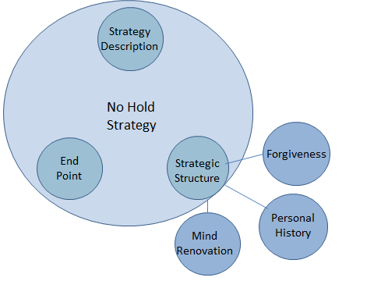
[Leader: Explain outline: These tactical families include: Forgiveness, Personal History, and Mind Renovation. Forgiveness and Personal History focus our attention on past events into present; then Mind Renovation is oriented to the present into the future. In our last class, we will return to the No Hold strategy to investigate its end point in more detail.]
In session 3 we moved forward to focus on the tactics of forgiveness connected to the No Hold strategy.
We recognized that Jesus’ criminal justice system is the context into which the tactics of forgiveness fit.
The next important concept we described in the context of forgiveness, was sin (lawlessness/criminal behavior).
The final concept we described in our last session was the activity of Satan as the accuser of the Christian believers.
We noted how forgiveness is defined:
[PP Slide 9: Definition]
aphiemi (NT:863), primarily, "to send forth, send away" [regarding] ‎(b) sins…
- ‎firstly signifies the remission [dismissal] of the punishment due to sinful conduct…
- ‎secondly, it involves the complete removal of the cause of offense
We emphasized that a court’s sole purpose is to establish guilt or innocence and dispense justice. Mercy and forgiveness are processes that could be termed “out of court settlements”. They are related to the maintenance of social order, but provide alternative processes to actual court action.
We then defined a family of forgiveness tactics included in the No Hold strategy:
[PP Slide 10: Definition]
- Receiving forgiveness from God
- Receiving forgiveness from others
- Granting forgiveness to others
In session 4, we investigated two of the forgiveness tactics;
- receiving forgiveness from God, and
- receiving forgiveness from others;
and practiced them.
We noted a way of interpreting the definition of forgiveness:
[PP Slide 11: Interpretation]
- To forgive – a sense of laying aside; getting rid of something; letting something go; sending something away.
  - Opposite of holding onto; keeping something close; grasping onto something
- If it’s laid aside, it’s gone.

Body:
In today’s class we will interact with some issues surrounding the third forgiveness tactic, which is granting forgiveness to another person.
To get us thinking about this reality,
(Group discussion 1: Question) - 5 minutes
As a full class, please discuss the following question.
[PP Slide 12: Question]
If it’s laid aside, it’s gone. What advantage would “having it gone” be to you?
[Leader: read question aloud]
Before we interact today with the tactic of granting forgiveness, we need to consider the relationship of confession (free admission) and repentance (changing your mind) to forgiveness.
[DRF note: In my concordance, the word “forgive” is used, by my count, 32 times in the New Testament; the word “confess” is used 10 times; and the word “repent” is used 27 times.]
The word “confess” is directly connected with “forgive” only twice, and “repent” is never directly connected with “forgive”. Last week we investigated both of the passages that directly connect confession with forgiveness.
[DRF note: maybe this research tells us is that forgiveness is not tied tightly to confession. It, of course, is better when confession is connected to forgiving because then peace can be established between the people involved. But neither confession nor repentance seems to be required in order for you to choose to forgive someone else. If it were, then you could be held in perpetual injury by a person who chooses to continue your injury by simply not confessing it.]

With this understanding in mind, let’s investigate the No Hold strategic tactic of granting forgiveness to another person.
Tactic 3: We grant forgiveness to others.
[PP Slide 13: Tactic 3]
The circumstances continue to get more complex as we move deeper into the tactics of forgiveness. So let’s try to set up our thinking by discussing the following question:
(Group discussion 2: Question) - 5 minutes
Starting with person #2, please discuss the following question.
[PP Slide 14: Question]
What kinds of difficulties have arisen regarding forgiving other people who have injured you in some way?
How have you solved the difficulties?
[Leader: read question aloud]

This tactic operates in two different mind-set environments:
- Mind-set 1 - A person who freely admits their evil work against you (whether they are a believer or not)
  - In effect, the person apologizes to you
- Mind-set 2 - A person who does not freely admit their evil work against you
  - A brother (fellow believer)
  - A non-believer
The mechanics of the first mind-set can be relatively simple – they confess, you forgive (if you are willing to), and peace then is restored between to two of you.
Jesus speaks to the second mind-set in the following ways:
Regarding a brother (relative or fellow believer):
This passage is part of a general teaching section in Matthew. It seems to be a brief side conversation Peter had with Jesus.
[PP Slide 15: Matt 18:21-22]
Matt 18:21-22
21 Then Peter came up and said to him, "Lord, how often will my brother sin against me, and I forgive him? As many as seven times?" 22 Jesus said to him, "I do not say to you seven times, but seventy times seven… ESV
[Leader: read the passage aloud.]
Notice that Jesus doesn’t counsel Peter about how to get his brother to “confess” his sin. He just says to forgive.
Regarding a non-believer:
This passage is part of Luke’s account of Jesus’ crucifixion.
[PP Slide 16: Luke 23:32-34]
Luke 23:32-34
33 And when they came to the place that is called The Skull, there they crucified him, and the criminals, one on his right and one on his left. 34 And Jesus said, "Father, forgive them, for they know not what they do." And they cast lots to divide his garments. ESV
[Leader: read the passage aloud.]
Who was Jesus referring to when He said that “they know not what they do”?
He didn’t explain.
It could be any or all, from the Romans, to the Jews, or even the “rulers of this age”. None of them really understood what the full results of their actions would be. And, as far as we know, none of them ended up confessing their sin.
(Group discussion 3: Question) - 10 minutes
Starting with person #3, please discuss the following question.
[PP Slide 17: Question]
…Jesus said, "Father, forgive them, for they know not what they do."…
What do you think the results would be for the two of you if you chose to forgive a person who didn’t confess an evil work done to you?
[Leader: read question aloud]

(Individual practice 1: Grant forgiveness to another person) – 5 Minutes
[Leader: read the following instruction to your class]
For the next 5 minutes please quietly ask God to remind you of something that has been done to you, but not willingly admitted to by another person. At this time, or during the coming week, please seriously consider forgiving the person(s) involved. Continue doing this tactic if God brings other situations to your mind.
Warning:
At this time, we need to look seriously at a warning Jesus gave us about forgiving:
[PP Slide 18: Matthew 6:9-15]
This warning is part of the Lord’s Prayer. We say this prayer every once in a while, but maybe don’t catch the warning in it.
Matthew 6:9-15
9 Pray then like this: "Our Father in heaven, hallowed be your name.
10 Your kingdom come, your will be done, on earth as it is in heaven.
11 Give us this day our daily bread,
12 and forgive us our debts, as we also have forgiven our debtors.
13 And lead us not into temptation, but deliver us from evil.
14 For if you forgive others their trespasses, your heavenly Father will also forgive you, 15 but if you do not forgive others their trespasses neither will your Father forgive your trespasses. ESV
[Leader: read the passage aloud.]

Each of us needs to consider what this teaching of Jesus might imply for our personal situation.
    - But - there is a practical solution:
      - Forgive EVERYTHING/EVERYONE

Conclusion
[DRF note: I would like again to share a few personal opinions at this point:
- It is to my personal advantage to forgive others whether or not they ask for forgiveness.
  - It is beneficial, but not absolutely necessary, for the other person to ask for the forgiveness in order for me to forgive them.
- Forgiving does NOT mean that what the other person did is OK.
  - If what they did was all right, there would be no need to forgive anything.
- Forgiving does not mean that I am required to allow the behavior to continue.
  - It is my personal decision, under God, to resist, or not resist, continued aggression.
  - However, if the aggression continues, I choose to continue forgiving the actions perpetrated against me even as I am, or am not, resisting.
It is not my intent in sharing these personal opinions to stimulate debate, but only to give you a sense of my personal thinking.]
OK, so now to review:
[PP Slide 19: Review]
- To forgive – a sense of laying aside; getting rid of something; letting something go; sending something away.
  - Opposite of holding onto; keeping something close; grasping onto something
- Forgiving also removes places in our souls owned by the kingdom of darkness.
  - If we then turn that place over to the Holy Spirit – asking Him to live in that place – the devil won’t be able to take it back.

You may have already picked up on a final point about the tactics of forgiveness: all of these forgiving processes interact with and support each other.

In our next three sessions we will attempt to deal with some of the No Hold strategic tactics targeted at personal history issues.
[PP Slide 19: Personal History Graphic]
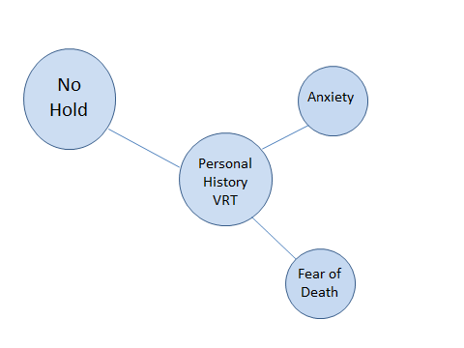
[Leader: who would be willing to close us in prayer?]

