[PP Slide 1: Title]
[Leader: “Please join me now in prayer”]
Dear Heavenly Father, “May the words of our mouths, and the meditations of our hearts be pleasing in Your sight, our Rock and our Redeemer.” In Jesus name, amen.
Introduction
Review:
In our first session, I described a strategy called No Hold which is rooted in, and inspired by, Jesus’ statement in John 14.
[PP slide 2: John 14:30-31]
We noted that there seems to be a dynamic relationship between reducing influence and growing influence between the two “kingdoms”.
[PP Slide 3: Inverse/build graphic]
We next identified some tactics that the devil uses to produce places of access and ownership in our lives.
[PP slide 4: Ephesians 4:25-28]
In relation to that understanding, we emphasized the role of the Holy Spirit in this dynamic process.
[PP slide 5: Eph 5:17-18]
In session 2, we talked about strategic structure – end point, pathways, and tactics.
We recognized our Biblical end point as full spiritual maturity,
[PP slide 6: – Eph 4:11-16]
and discussed a Biblical pathway called “standing firm”.
[PP slide 7: – Eph 6:13]
And we looked forward at several families of tactics connected to the No Hold strategy.
(PP Slide 8: Outline)
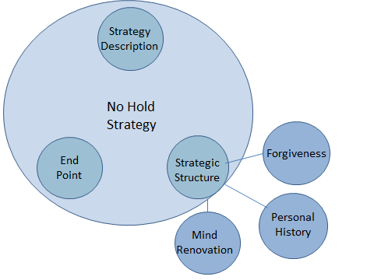
[Leader: Explain outline: These tactical families include: Forgiveness, Personal History, and Mind Renovation. Forgiveness and Personal History focus our attention on past events into present; then Mind Renovation is oriented to the present into the future. In our last class, we will return to the No Hold strategy to investigate its end point in more detail.]
My hope is that we will be able together to consider practical, experience-tested tactics available to us Christians which will reduce our exposure to one kingdom while increasing exposure to the other.
Body:
In this session and the next two, I hope to focus our attention on the tactics of forgiveness.
[PP Slide 9: Forgiveness graphic]
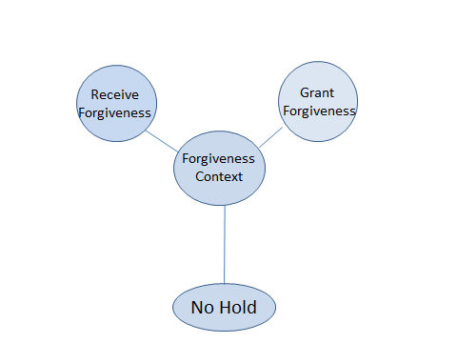
To start out, let’s briefly discuss the following question.
(Group discussion 2: Question) - 5 minutes
Starting with person #2, in 1 minute each, please discuss the following question:
[PP Slide 10: Question]
When you think of forgiveness, what comes to your mind?
[Leader: read question aloud]
- Government
In order to understand forgiveness; we must fit it into the context of Jesus’ government.
First Jesus created His government by and for Himself.
We will let Paul speak to this issue from his letter to the Colossians. The context is his statement about the Preeminence of Christ in the first chapter.
[PP Slide 11: Colossians 1:15-17]
Colossians 1:15-17
15 He (Jesus) is the image [likeness/copy] of the invisible God, the firstborn [prototype] of all creation. 16 For by him all things were created, in heaven and on earth, visible and invisible, whether thrones or dominions or rulers or authorities—all things were created through him and for him. 17 And he is before all things, and in him all things hold together. ESV
[Leader: Read passage aloud]
[DRF Note: Thrones, etc. refer to governmental structure. The word “Throne” refers both to the chair, and the one who sits on it. Notice that several of these words, separated by “or”, refer to aspects of governmental structure.]

Second His government includes a legal system--including His court
[PP Slide 12: Revelation 20:11-12]
The context of this passage is John’s vision of the defeat of Satan and the new (renewed) heaven and earth.
Revelation 20:11-12
11 Then I saw a great white throne and him who was seated on it. From his presence earth and sky fled away, and no place was found for them. 12 And I saw the dead, great and small, standing before the throne, and books were opened. Then another book was opened, which is the book of life. And the dead were judged [tried] by what was written in the books, according to what they had done. ESV
[Leader: Read passage aloud]

[DRF Note:
- Again the reference to “throne”; a description of governmental structure.
- This term - judged - describes a trial process.
  - Trial is another word for a court of law with a presiding judge.]

Third He gave us a summary of the laws of His government (10 Commandments)
[PP Slide 13: Deuteronomy 5:1-5]
Deuteronomy 5:1-5
Moses summoned all Israel and said:
1 And Moses summoned all Israel and said to them, "Hear, O Israel, the statutes and the rules that I speak in your hearing today, and you shall learn them and be careful to do them. 2 The Lord our God made a covenant with us in Horeb. 3 Not with our fathers did the Lord make this covenant, but with us, who are all of us here alive today. 4 The Lord spoke with you face to face at the mountain, out of the midst of the fire, 5 while I stood between the Lord and you at that time, to declare to you the word of the Lord. ESV
[Leader: Read passage aloud]

[DRF Note:
- The word “statutes, and rules” in this context gives a lawful form to the instruction.
- These “statutes and rules” reveal God’s character and His expectation regarding the social lifestyle of His chosen (Israelite) people.]

(Group discussion 3: Question) - 5 minutes
Starting with person #3, please discuss the following question:
[PP Slide 14: Question]
…whether thrones or dominions or rulers or authorities…
How do you think that, after creating these governmental structures and establishing these laws, God might look after His government?
[Leader: read question aloud]

[DRF note: Please notice that a court’s sole purpose is to establish guilt or innocence and dispense justice. Mercy and forgiveness are processes that could be termed “out of court settlements”. They are related to the maintenance of order, but provide alternative processes to actual court action.]
- Sin
The next concept important to describe in the context of forgiveness, is sin.
(Group discussion 4: Question) - 5 minutes
Starting with person #4, in 1 minute each, please discuss the following question:
[PP Slide 15: Question]
When you think of sin, what comes to your mind?
[Leader: please read question aloud]

The concept of sin/lawlessness includes three ideas critical to our discussion this morning:
[PP Slide 16: Definition]
It embodies the ideas of:
  - missing the mark moving toward total destruction;
  - the sinner not able to share in the prize (eternal life);
  - and God’s enforcement processes
    - including court-ordered punishment
[Leader: read the definition aloud]
It is in the context of criminal behavior that the concept of forgiveness exists.
[PP Slide 17: Definition]
Forgiveness:
aphiemi (NT:863), primarily, "to send forth, send away" [regarding] ‎(b) sins…
- ‎firstly signifies the remission [dismissal] of the punishment due to sinful conduct…
- ‎secondly, it involves the complete removal of the cause of offense
[Leader: read definition aloud beginning with the word “primarily”.]
[Leader: Remind your participants - NT or OT stands for New or Old Testament. The number is the word number in Strong’s Greek/Hebrew Definitions, and the definition is also from Strong’s reference work.]

- Satan:
The third reality necessary to recognize is the activity of Satan. You are probably aware that “Satan” is not someone’s name. It is a job title that describes a tactical position in a strategic pathway. This position is to be an adversary, one that opposes or resists. In the Biblical context, the one we call “Satan” opposes/resists God’s sovereignty
This adversarial activity fills Satan’s kingdom, and focuses on God’s reign and God’s people. His activity in God’s government, including the legal system is documented. The following passage summarizes his activity regarding God’s people.
[PP Slide 18: Rev 12:10-12]
Rev 12: 10-12
10 And I heard a loud voice in heaven, saying, "Now the salvation and the power and the kingdom of our God and the authority of his Christ have come, for the accuser of our brothers has been thrown down, who accuses them day and night before our God. 11 And they have conquered him by the blood of the Lamb and by the word of their testimony, for they loved not their lives even unto death. 12 Therefore, rejoice O heavens and you who dwell in them! But woe to you, O earth and sea, for the devil has come down to you in great wrath, because he knows that his time is short!" ESV
[Leader: Read passage aloud]
[DRF note: This statement begs a few questions:
- Where does he lodge these accusations “before our God”?
In my opinion, he formally lodges them in God’s heavenly court (and also often in our media - and spreads them through gossip networks.)
- Where does he get his ammunition?
Probably from our sinful actions (you know – when we do Satan’s tactics).]

[DRF note: In my opinion, forgiveness is not the same as being justified (justice having been served). Justification is court action whereby Jesus takes his suffering and death and places them as full payment for a guilty person’s punishments. The court then “acquits” [discharges completely] that person and has no more legal interest in them.
Forgiveness, on the other hand, has to do with people living at peace with one another. This process could be termed an “out of court settlement”. It is related to the maintenance of social order, but provides an alternative processes to actual court action. When I speak of “people”, I am referring to our relations with God as well as each other.]

[Leader: If time permits, receive and discuss questions]

What questions might you have at this time?

Conclusion:
To summarize this session, Forgiveness needs to be understood in the context of God’s governmental structure. God’s government includes a way to deal with criminality. His court system is set up to establish guilt or innocence and dispense justice. Forgiveness is a part of His legal system that allows for “out of court” settlements.
[PP Slide19: forgiveness Graphic]
In the next two sessions we will focus on, and practice, the tactics of receiving and granting forgiveness.
What, you ask, does all this have to do with No Hold? Now that’s a very good question. I’m glad you asked.
Group discussion 5: Question) - 5 minutes
Starting with person #1, in 1 minute each, please discuss the following question:
[PP Slide20: Question]
Can you think of any ways that forgiveness might reduce the devil’s influence in your life?
[Leader: please read question aloud]

“Receiving Forgiveness” involves both seeking forgiveness from another person, and granting forgiveness to another person.
Receiving forgiveness from another person often needs to be pursued with much Godly counsel, quietness, and sensitivity.
Receiving forgiveness involves humbly approaching the other person:
No excuses, rationalizations, blaming, etc.

[Leader: who would be willing to close us in prayer?]

