[PP slide 1: Title]
[Leader: Read Housekeeping issues:]
- Students, please reintroduce your selves to each other one more time.
- Please also keep in mind during our group discussions that some of us are quieter than others. Both styles are just fine, so please remember to allow everyone time and opportunity to speak.
[Leader: “Please join me now in prayer”]
Dear Heavenly Father, “May the words of our mouths, and the meditations of our hearts be pleasing in Your sight, our Rock and our Redeemer.” In Jesus’ name, amen.

Introduction :
[PP slide 2: Outline]
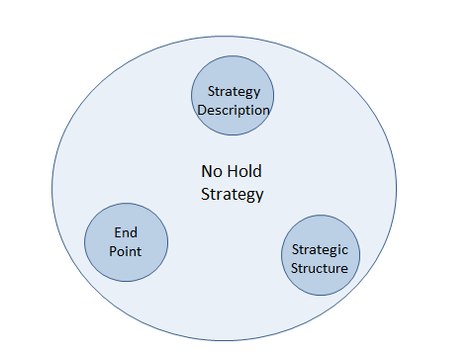

During these first two sessions we will be dissecting a strategy called “No Hold”. Then, for the next 9 sessions, we will be interacting with several tactics connected to this strategy. In our last session, we will be looking deeper at the end point, or big focus, of the strategy, which will be presented briefly later today.
Review
In our first session, I described a strategy called No Hold which is rooted in, and inspired by, Jesus’ statement in John 14.
[PP slide 3: John 14:30-31]
We noted that there seems to be a dynamic relationship between reducing influence and growing influence between the two “kingdoms”.
[PP Slide 4: Inverse/build graphic]
We next identified some tactics that the devil uses to produce places of access and ownership in our lives.
[PP slide 5: Ephesians 4:25-27]
In relation to that understanding, we emphasized the role of the Holy Spirit in this dynamic process.
[PP slide 6: Eph 5:17-18]

Today we will be concentrating on strategic structure.
[PP slide 7: Outline]
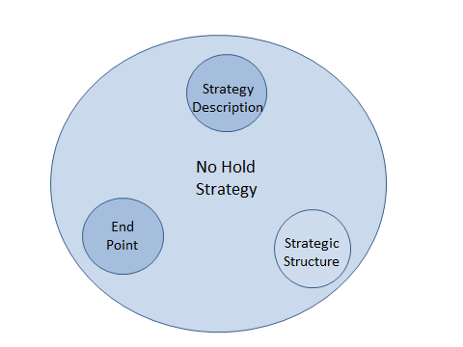
To this end, please get into your small groups to discuss what you learned from God this past week (or appropriate time period) as you considered the John 14 passage.
[PP slide 8: John 14:30-31]
John 14:30-31
30 I will no longer talk much with you, for the ruler of this world is coming. He has no claim/hold on me, 31 but I do as the Father has commanded me, so that the world may know that I love the Father. ESV
[Leader: read passage aloud]
[Group Discussion 1:] - 5Minutes
Starting with person #1, please share (voluntarily) with your group what you learned this week in your personal exercise.

Body:
In this session we will be concentrating on the No Hold strategy’s structural elements. The structural elements of a strategy include an End Point, Pathways, and Tactics.
So, let’s start with the term “Strategy” – what does that word even mean? Perhaps you have heard it used in certain ways, like War Strategy; or Business Strategy; or maybe Game Strategy.
[PP slide 9: definition]
A strategy is a general plan of action that is built to accomplish the end point in a specific contest.
[Leader: read this and the following definitions aloud]
Strategic plans contain structural elements such as “end points”, “pathways”, and “tactics”.
[PP slide 10: Definition]
The strategic end point describes what will be accomplished.
[PP slide 11: Definition]
Strategic pathways, provide direction and support for tactics
[PP slide 12: definition]
Tactics, are the specific actions that need to be taken in order for a strategy to be successful.
Maybe an illustration would be helpful at this time: Anybody in here ever play football/soccer?
[PP slide 13: Illustration]
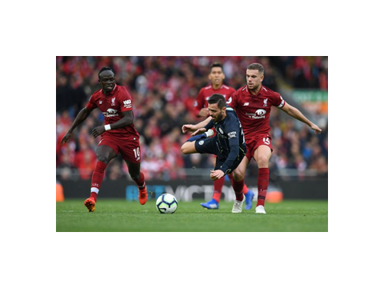
Let’s consider the game strategy of football/soccer. Winning the game is the end-point. A team wins the game by using offensive and defensive pathways, or “plays”, designed to identify and allow tactics regarding ball handling and body positioning to prevent or score goals.
One player may recognize and choose a pathway/play that moves along a sideline, while a different player may take a more center-of-field path. The strategy supports both pathways/plays, which are imbedded in it.
First, what is the end point of the No Hold strategy?
[PP slide 14: End Point]
The end point of the No Hold strategy is to attain full spiritual adulthood.
[Leader: read definition aloud]
This end point is expressed several different ways in the Bible. Paul points to it in Ephesians 4.
[PP slide 15: Eph 4:11-16]
Ephesians 4:11-16
11 And he (Jesus) gave the apostles, the prophets, the evangelists, the pastors and teachers, 12 to equip the saints for the work of ministry, for building up the body of Christ, 13 until we all attain to the unity of the faith and of the knowledge of the Son of God, to mature manhood, to the measure of the stature of the fullness of Christ, 14 so that we may no longer be children, tossed to and fro by the waves and carried about by every wind of doctrine, by human cunning, by craftiness in deceitful schemes. 15 Rather, speaking the truth in love, we are to grow up in every way into him who is the head, into Christ, 16 from whom the whole body, joined and held together by every joint with which it is equipped, when each part is working properly, makes the body grow so that it builds itself up in love. ESV [Leader: Read passage aloud.]

Next, “Standing firm”, as Paul uses it in Ephesians, is, in my opinion, an example of a pathway in the No Hold strategy.
Let’s look for a moment at what Paul says about standing firm. The context has to do with spiritual warfare. In the battle context of Ephesians 6, No Hold is about getting to the place where we can (stand firm [no retreat]; step forward; stand firm; step forward; stand firm) until we reach our end point.
[PP slide 16: Ephesians 6: 10-13]

Ephesians 6:10-13
10 Finally, be strong in the Lord and in the strength of his might. 11 Put on the whole armor of God that you may be able to stand against the schemes of the devil. 12 For we do not wrestle against flesh and blood, but against the rulers, against the authorities, against the cosmic powers over this present darkness, against the spiritual forces of evil in the heavenly places. 13 Therefore take up the whole armor of God that you may be able to withstand in the evil day, and having done all, to stand firm. ESV
[Leader – read passage aloud.]
(Group discussion 2) - 5 Minutes
Starting with person #2, please discuss this question:
[PP slide 17: question]
…and having done all, to stand firm…
What are you presently doing to stand the way Paul talks about it?
[Leader: read the question aloud]

When you think about it, the Bible also uses some other terms to describe similar pathways:
- You’re probably familiar with the term “overcoming”.
- You’ve also heard about “running in a race”.
Standing, overcoming, and racing are, in my opinion, all just different pathways supported by the same strategic structure. These pathways are supported by the No Hold strategy, and are imbedded in it. Any of these Biblical pathways will bring a follower to the end point.
Finally, we will focus on No Hold tactics in later class sessions.
Keeping our present focus on Pathways:
(Group discussion 4) - 10 Minutes
Starting with person #4, please discuss the following question:
[PP slide 18: question]
How would you connect Paul’s statement:
“…after you have done everything, to stand [firm/no retreat].” (Eph 6:13)
With Jesus’ statement:
“…. He has no claim/hold [nothing] on me” (John 14:30)?
[Leader: Read the question aloud. At the end of 5 Minutes, ask Person #4 to present one connection discussed in their group. Record the connections.]
To bring this down to a personal level:
(Group discussion 5) - 10 Minutes
Starting with person #1, please discuss the following question:
[PP slide 19: Question]
…He has no claim (hold) on me…
What benefit would there be to you if the devil had “No Hold” on you?
Leader: read the question aloud]
Person #5; please present to the large group one benefit discussed in your small group.
[Leader: Record the benefits.]
[DRF note: how well do you think you could fight, even when you were fully armored and armed, if you had an open wound on your backside, and an enemy soldier was back there sticking a stick in the wound and swirling it around?]
[Leader: if time permits, seek questions from students]
What questions might you have at this point?
Conclusion:
[DRF note: This No Hold strategy that I am presenting here has grown out of my own personal struggle learning how to DO what I read in Ephesians 6 about standing firm in battle.]
[DRF Note: Please remember: Standing firm is, in my opinion, just one pathway among several options. There are other pathways, or maybe just other ways that the Bible describes the same pathway; for instance, “overcoming”, or “running in the race”, to name a few. Standing firm is just the expression that has caught my attention.]
Again, let me point out: strategic theory is normally not too threatening. It may often be just boring.
The doing, though…actually taking some action – and living with the results - now, that’s a completely different matter.
First of all, we have to understand HOW to do an action, and then we need to Practice the action, and then, maybe, we might actually CONTINUE to do it. You know, make a habit out of it.
The rest of our class sessions (except for the final session) will focus on tactics –things to Do.
[PP slide 20: Outline]
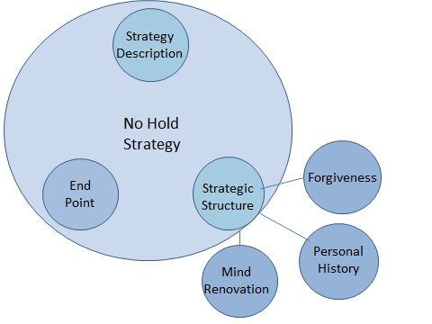
[Leader: Explain Outline: In coming sessions, I plan to present three, can I say, tactical families which target some of the access points that probably exist in each one of us to some extent or other. These tactical families include: Forgiveness, Personal History, and Mind Renovation. Forgiveness and Personal History tactics focus our attention mostly on past events into the present. Mind Renovation is oriented to the present into the future. In our last class, we will return to the No Hold strategy to investigate its strategic end point in more detail.]
My hope is that we will be able together to consider, and practice, some practical tactics available to us Christians that will reduce our exposure to the “ruler of this world” influence and increase God’s influence.
[Leader: Who would be willing to close us in prayer?]

