[PP Slide 1: Title]
[Leader: copy file [1 Strategy Description 1a.docx] for each participant]
(Group discussion 1) - 5 Minutes
Get acquainted:
Before I open the class in prayer, please move into small groups of 3 – 4.
Please then number yourselves – each person taking a number - 1 through 4.
Starting with person #1; In 1 minute or less (each), please answer the following questions:
[PP Slide 2: Questions] - 4 Minutes
What is your first name?
If you were an animal, what would you be?
[Leader: Use my introduction as a model for yours, or build your own introduction. Use “animal”, or substitute something culturally appropriate instead of an animal.]
While you’re moving around, let me introduce myself:
[DRF note:
My name is Daniel
I would be a puppy in an old dog’s body – usually reserved, but, also liable to run in wagging my tail so hard that my whole rump swings; jumping up and trying to lick someone’s face].
As you come back to class next week, please sit near the other people in your group.

[Leader: “Please join me now in prayer”]
Dear Heavenly Father, “May the words of our mouths, and the meditations of our hearts be pleasing in Your sight, our Rock and our Redeemer.” In Jesus’ name, amen.
Introduction:
Ok –so let me start by saying…
[DRF note:
When will it ever end???
Have you ever said something like that to yourself? It seems that my whole life has been one spiritual challenge after another. There have been several times when I wondered if I was making any progress at all.
Regarding the wider world, I have also come to recognize that the global political and religious trends building through the past century are probably going to continue at least through the rest of my life-span.
I realized several years ago that I would need to change in significant ways if I was going to be able to stand firm as a Christian. To that end, I have been searching in the Bible for specific, practical, and effective ways to change spiritually.]
In this set of class sessions I plan to share some of those discoveries.
Body:
Today I will be describing a strategy for spiritual growth called No Hold.

[PP slide 3: Outline]
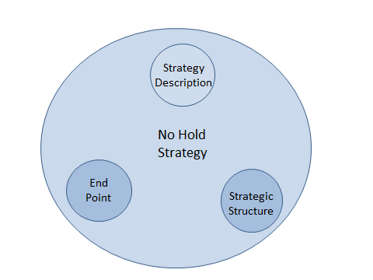
Before we go any further, we need to define the larger political context in which we find ourselves. The Bible describes two kingdoms which have authority in the universe at this time:
- The kingdom of God (also called the kingdom of light); and
- The kingdom of the one the bible calls the devil or Satan (also called the kingdom of darkness).
The No Hold strategy is generally about how Christians grow up spiritually. It is about minimizing the influence of the kingdom of darkness, and, at the same time, increasing the influence of the Kingdom of light in a believer’s life.
To illustrate this idea, take a look at this graph:
[PP slide 4: Inverse graph]
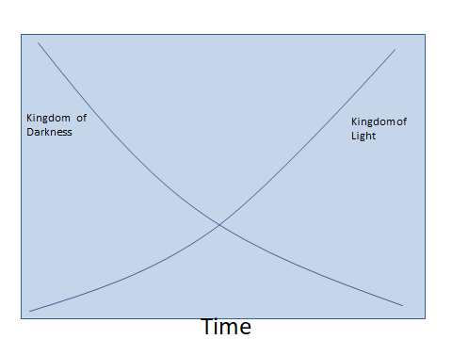
This graph represents a way to illustrate the NO Hold strategy. We will return to this graph later, but for now, please recognize that the two kingdoms seem to play off each other in some dynamic way.
At our spiritual birth (represented by the far left point on the time line), most of us are highly influenced by the kingdom of darkness. Then, as we grow spiritually, this kingdom of darkness influence is slowly removed, and kingdom of light influence increases until the weight of influence is switched from the kingdom of darkness to the kingdom of light.
So, why No Hold?
- So that our spiritual battles will be more winning and less loosing;
- So that the spiritual injuries that we have already received in our” inner man” are healed up;
- So that we take fewer injuries going forward;
- So that we have fewer casualties in our spiritual family.
The “why” also has to do with being transformed, in the process of growing up, into a person who will live forever with the One who treasures us, and, in return, treasuring Him (and each other).
It’s so simple to say – win the war and be healed and transformed in the process!
Beautiful!
So where does the term “No Hold” come from you ask?
Well, the No Hold strategy is rooted in, and inspired by, a phrase found at the end of the conversation Jesus had with His disciples during the last supper. It is found in John 14.
Let’s look at it together.
[PP slide 5: John 14:30-31]
John 14:30-31
30 I will no longer talk much with you, for the ruler of this world is coming. He has no claim (NIV - hold) on me, 31 but I do as the Father has commanded me, so that the world may know that I love the Father. ESV
[Leader: read the passage aloud.]
Let’s look closely at the phrase that Jesus uses in this passage; but, before we do, we need to understand a convention that we will be using throughout these sessions when a Biblical term is defined. NT or OT stands for New or Old Testament. The number is the word number in Strong’s Greek/Hebrew Definitions, and the definition is also from Strong’s reference work.
Having said that, let’s see how the term is defined:
[PP slide 6: Definition]
…He has no claim/hold on me…
NT:3762 ‎ ‎; ‎oudeis from NT:3761 and NT:1520; not even one (man, woman or thing), i.e. none, nobody, nothing:
[Leader: read the definition aloud starting with the word “not”.]
What does He even mean?
(Group discussion 2) - 5 Minutes
Starting with person #1, please discuss the following question:
[PP slide 7: Question]
…He has no claim/hold on me…
What do you think Jesus means when He says “He has no claim/hold on me”?
[Leader: read the question aloud. When the discussion time is up, share the following thoughts]
[DRF note: No claim/hold [lit. nothing in me] - no possession; no ability to influence; no access points]
Let’s take a look again at the John 14 passage.
[PP slide 8: John 14:30-31]
John 14:30-31
30 I will no longer talk much with you, for the ruler of this world is coming. He has no claim/hold on me, 31 but I do as the Father has commanded me, so that the world may know that I love the Father. ESV
[Leader: read passage aloud]
Jesus says in effect, No Hold: completely empty of [possessions; influence; access points, leverage, etc.] belonging to the ruler of this world.
Also…
Completely filled with [love/compassion/charity] for the father.
And,
I do.
Amazing!

So, let’s talk together about this for a moment.

(Group discussion 3) - 10 Minutes
Starting with person #2, please discuss the following question:
[PP slide 9: Question]
…He has no claim/hold on me…
What advantages could we gain if we decrease the “hold” the ruler of this world has on us?
[Leader: read the question aloud. After the end of 5 Minutes, ask Person #2 from each group (one at a time) to please present one comment from their group. If possible, record the comments in a way that all participants are able to view them.]
The No Hold strategy of producing spiritual change includes two related positive processes. One side is removing (from our “inner man” landscape) places accessible by the “ruler of this world”; the other side is our “inner man” being brought to full maturity by the Spirit of God.
At this point, let’s look again at the graph.
[PP slide 10: Inverse-build graphic]
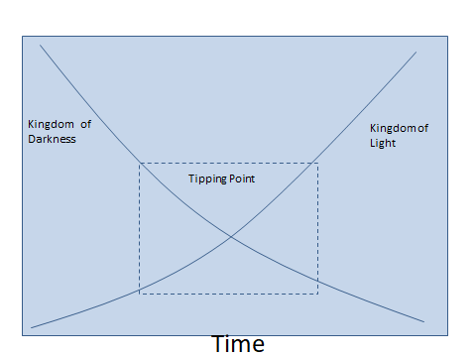
This process – emptying/filling – is a dynamic process. A believer who follows the No Hold strategy eventually may pass a “tipping point”.
[Leader: explain “tipping Point”. Share your own experience, or quote mine.]
[DRF note: This is what I mean by the term “tipping point”. During my early years, it seemed that my walk was full of struggle, injury, and loss. Then, somewhere in the middle years, I gradually became aware that God was replacing what was being removed with better things. As I became more aware of this reality, my walk ceased to be “drudgery”, and became an “adventure”.]

At this time, let’s bring in a few other passages from the Bible. I hope in this way to look at some related issues.
[DRF note: To consider this in a wider context, it is my personal opinion that the kingdom of darkness is following its own strategy – the end point of which is to force God to treat the devil as an equal (see Ezekiel 28). If I am correct, then all of the ongoing influence from that direction is actually the result of - can I put it this way – “agents” of the devil’s kingdom following strategic pathways and “doing” a set of tactics connected to this strategy.]
Here is an example of what Paul says about places, in a person’s inner man, owned by the devil. This instruction comes from his letter to the Ephesians. He’s talking about unity and maturity in the church.
[PP slide 11: Ephesians 4:25-32]

Ephesians 4:25-32
25 Therefore each of you must put off falsehood and speak truthfully to his neighbor, for we are all members of one body. 26 "In your anger do not sin": Do not let the sun go down while you are still angry, 27 and do not give the devil a foothold [a place to occupy/live]. 28 He who has been stealing must steal no longer, but must work, doing something useful with his own hands, that he may have something to share with those in need.
29 Do not let any unwholesome talk come out of your mouths, but only what is helpful for building others up according to their needs, that it may benefit those who listen. 30 And do not grieve the Holy Spirit of God, with whom you were sealed for the day of redemption. 31 Get rid of all bitterness, rage and anger, brawling and slander, along with every form of malice. 32 Be kind and compassionate to one another, forgiving each other, just as in Christ God forgave you. ESV
[Leader: read passage aloud]
In this passage, Paul reveals several activities through which we give the devil a place to occupy/live in our inner lives. This list is not exhaustive. There are many other activities that produce access places. If the devil occupies a place, surely he will influence us from that place. Paul also provides alternate kingdom of light activities that do not provide places for the devil to occupy.
[PP slide 12: Table]

…do not give the devil a foothold [a place to occupy/live]…
Kingdom of Darkness Activity | Kingdom of Light Activity
Lying | Speak the truth
Anger | Don’t let the sun go down on anger
Stealing | Do honest work
Unwholesome talk | Helpful for building each other up
Grieve the Holy Spirit | Do not
Bitterness | Be kind and compassionate, and forgiving to one another
Rage & Anger
Brawling
Slander
Malice

From the places the devil owns in a person’s inner man (call them Access points), he promotes his own interests. It is from these access points that his agents influence a person to continue, and deepen, their involvement in his kingdom. This activity always produces an evil (which the Bible defines as injury, destruction, or waste) result in the process.
(Group discussion 3) - 10 Minutes
Starting with person #3, please discuss this question:
[PP slide 13: Question]
…do not give the devil a foothold [a place to occupy/live]…
Do you think there might be ways to remove the access points which enable the devil’s “agents” to apply/do their tactics?
[Leader: read the question aloud. At the end of 5 Minutes, ask Person #3 from each group to please share the ways identified in their group. Record their comments.]
In this line of thinking, consider what Paul says to the Corinthian church. He’s talking about God’s hidden wisdom.
[PP slide 14: 1 Cor 2:6-8]
1 Corinthians 2:6-8
6 Yet among the mature we do impart wisdom, although it is not a wisdom of this age or of the rulers of this age, who are doomed to pass away. 7 But we impart a secret and hidden wisdom of God, which God decreed before the ages for our glory. 8 None of the rulers of this age understood this, for if they had, they would not have crucified the Lord of glory. ESV
[Leader: read passage aloud]
[DRF note: If I understand this passage correctly, the devil’s strategy has already failed partly due to inaccurate intelligence. Tactics are developed from strategy. Since his strategy has already failed, his tactics are probably also vulnerable to be defeated.]
In Ephesians 5, Paul seems to be saying that the removal of kingdom of darkness “hold” makes more room for the Holy Spirit. Or, maybe you could say that the Holy Spirit is able to “crowd out/remove” the influence of the devil.
[PP slide 15: Eph 5:17-21]
Ephesians 5:17-21
17 Therefore do not be foolish, but understand [put together] what the will of the Lord is. 18 And do not get drunk with wine, for that is debauchery, but be [continually] filled [to the brim] with the Spirit, 19 addressing one another in psalms and hymns and spiritual songs, singing and making melody to the Lord with all your heart, 20 giving thanks always and for everything to God the Father in the name of our Lord Jesus Christ, 21 submitting to one another out of reverence for Christ. ESV
[Leader: read passage aloud]
An illustration may be helpful here:
Explain Jug Illustration: Suppose you have a 1 gallon/liter glass jug. Into the jug you place three chicken-egg-sized stones. Then, you fill up the jug completely (to the brim) with water.
(Group discussion 4) - 5 Minutes
As an entire class please answer the following question.
[PP slide 16: Question]
…be [continually] filled [to the brim] with the Spirit…
What are some ways that you could increase the volume of water in the jug?
[Leader: read question aloud. After 5 minutes, give (or agree if the answer is expressed in the discussion). Answer: remove the stones and add more water.]
In the following class sessions, we will learn several biblical activities (tactics) which are able to help us remove the devil (and his kingdom of darkness influence) from occupied places in our lives and replace him with the Holy Spirit and kingdom of light influence.
(Group discussion 5) - 5 Minutes
Starting with person #4, please discuss this question:
[PP slide 17: Question]
How would a person come to the point of desiring to pursue this No Hold strategy?
[Leader: read the question aloud. At the end of the time limit, move on to the Conclusion]
Conclusion:
Along with “secret wisdom” (accurate intelligence), the bible also contains tactics that are able to reduce the “hold” that the kingdom of darkness has on a Christian. Tactics are actions defined in a strategy.
In this first session we have been describing a strategy called “No Hold”.
[PP slide 18: Outline]
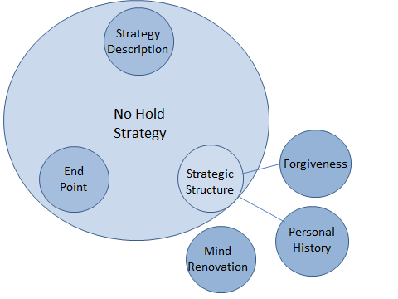

In the next session we will interact with the strategic structure: End Point, Pathways, and Tactics. Then, for the next 9 weeks, we will be interacting with several tactical families connected to this strategy. In our last class, we will be looking deeper at the end point, or big focus, of the strategy.
Strategic theory is normally not too threatening. It may often be just…yawn… boring.
The doing, though…actually taking some action – and living with the results - now, that’s a completely different matter.
First of all, we have to understand HOW to do an action, and then we need to Practice the action, and then, maybe, we might actually CONTINUE to do it. You know, make a habit out of it.
[Personal practice # 1:]
[Leader: pass out the No Hold Worksheet]
In order to get prepared, please complete this exercise before our next session. At the beginning of our next session, you will be given an opportunity to voluntarily share your insights.

[Leader: who will be willing to close our session in prayer?]

No Hold Worksheet
Please read the following passage each day between now and our next session. Before you start reading, please pray and ask God to reveal something to you from the passage. Write down what God reveals to you about the passage. You will have an opportunity to voluntarily share your insights with your small group in our next session.
John 14:30-31
30 I will no longer talk much with you, for the ruler of this world is coming. He has no claim (NIV – hold) on me, 31 but I do as the Father has commanded me, so that the world may know that I love the Father. ESV

